1. Cumulative Number of Licenses granted under Section 17 of the Sri Lanka Telecommunications Act No 25 of 1991 as amended.

Category of Service | 2016 June
- Fixed Access Telephone | 3
- Cellular Mobile Telephone | 5
- Data Communications (Facility based) | 2
- Data Communications (Non-facility based & Internet Service Providers (ISP)) & ISP’s | 9
- Trunk Mobile Radio | 1
- International Telecommunication Operator | 7
- Direct-to-Home Satellite Broadcasting Services | 4
- Cable TV Distribution Network | 3
- Satellite Services | 1
- Other | 2
Sub Total | 37
SLTL, Lanka Bell, Dialog Broadband are entitled to provide Pay phone and Data services according to their licences.

  - Fixed Access Telephone Operators
No | Operator | Date of Issue | Period | Date of Expiry
1 | Dialog Broadband Networks (Pvt.) Ltd. | 10.11.2005 | Ten years (10) | 10.11.2015**
2 | Lanka Bell Ltd. | 26.02.1996 | Twenty years (20) | 26.02.2016**
3 | Sri Lanka Telecom PLC | 09.02.2012 | Ten years (10) | 09.02.2022
** - Renewal Process in Progress

  - Cellular Mobile Telephone Operators
No | Operator | Date of Issue | Period | Date of Expiry
1 | Bharti Airtel Lanka (Pvt.) Ltd. | 12.04.2007 | Ten years(10) | 12.04.2017
2 | Dialog Axiata PLC | 28.09.2013 | Ten years(10) | 28.09.2023
3 | Etisalat Lanka (Pvt.) Ltd. | 13.09.2008 | Ten years(10) | 13.09.2018
4 | Hutchison Telecommunications Lanka (Pvt.) Ltd. | 11.02.2012 | Ten years(10) | 11.02.2022
5 | Mobitel (Pvt.) Ltd. | 10.02.2013 | Ten years(10) | 10.02.2023

  - Data Communications (Facility Based) Operators
No | Operator | Date of Issue | Period | Date of Expiry
1 | Lanka Communication Services (Pvt.) Ltd. | 04.07.2011 | Ten years (10) | 04.07.2021
2 | Societe International Telecommunications Aeronautiques (SITA) | 06.08.2012 | Five years (05) | 06.08.2017

  - Data Communications (Non Facilities Based) - Internet Service Providers (ISP)

No | Operator | Date of Issue | Period | Date of Expiry
1 | Bharti Airtel Lanka (Pvt.) Ltd | 28.03.2014 | Five years (05) | 28.03.2019
2 | Dialog Axiata PLC. | 01.11.2011 | Five years (05) | 01.11.2016
3 | Dialog Broadband Networks (Pvt.) Ltd. | 05.12.2013 | Five years (05) | 05.12.2018
4 | Etisalat Lanka (Pvt.) Ltd. | 23.03.2014 | Five years (05) | 23.03.2019
5 | Eureka Technology Partners (Pvt.) Ltd. | 16.08.2011 | Five years (05) | 16.08.2016
6 | Hutchison Tele Lanka (Pvt.) Ltd. | 01.03.2013 | Five years (05) | 01.03.2018
7 | Lanka Education and Research Network | 01.09.2011 | Five years (05) | 01.09.2016
8 | Mobitel (Pvt.) Ltd. | 01.02.2012 | Five years (05) | 01.02.2017
9 | TATA Communications Lanka Ltd. | 10.02.2015 | Five years (05) | 10.02.2020

  - Trunk Mobile Radio Operators
No | Operator | Date of Issue | Period | Date of Expiry
01 | Dynacom Engineering (Pvt.) Ltd | 25.02.2013 | Five years(05) | 25.02.2018

  - International Telecommunication Operators
No | Operator | Date of Issue | Period | Date of Expiry
1 | Bharti Airtel Lanka (Pvt.) Ltd. | 01.12.2007 | Ten years(10) | 01.12.2017
2 | Dialog Axiata PLC | 28.02.2013 | Ten years (10) | 28.02.2023
3 | Etisalat Lanka (Pvt.) Ltd. | 28.02.2013 | Ten years (10) | 28.02.2023
4 | Hutchison Telecommunications Lanka (Pvt.) Ltd. | 28.02.2015 | Ten years (10) | 28.02.2025
5 | Lanka Bell Ltd. | 28.02.2013 | Ten years(10) | 28.02.2023
6 | Mobitel (Pvt.) Ltd. | 07.03.2013 | Ten years(10) | 07.03.2023
7 | TATA Communications Lanka (Pvt.) Ltd. | 06.06.2013 | Ten years (10) | 06.06.2023

  - Direct-to-Home Satellite Broadcasting Services Operators
No | Operator | Date of Issue | Period | Date of Expiry
1 | Dialog Television (Pvt.) Ltd | 01.02.2012 | Five years(05) | 01.02.2017
2 | DISH TV Lanka (Pvt.) Ltd | 30.11.2013 | Three years(03) | 18.10.2016
3 | Future Satcom Holding (Pvt.) Ltd., | 18.10.2011 | Five years (05) | 18.10.2016
4 | MTV Channel (Pvt.) Ltd., | 15.10.2015 | Five years (05) | 15.10.2020

  - Cable TV Distribution Network Operators
No | Operator | Date of Issue | Period | Date of Expiry
01 | Ask Cable Vision (Pvt.) Ltd | 01.03.2013 | Five years(05) | 01.03.2018
02 | Lanka Broadband Networks Ltd | 22.12.2011 | Five years (05) | 22.12.2016
03 | Lanka Cable & Satellite Network (Pvt.) Ltd | 07.06.2012 | Five years(05) | 07.06.2017

  - Satellite Services

No | Operator | Date of Issue | Period | Date of Expiry
01 | Supreme Sat (Pvt.) Ltd | 10.05.2013 | Five years (05) | 10.05.2018

  - Other Operators
No | Operator | Date of Issue | Period | Date of Expiry
01 | Dialog Broadband Networks (Pvt.) Ltd | 08.05.1995 | Twenty years(20) | 08.05.2015***
02 | Tritel Services (Pvt.)Ltd | 20.09.2010 | Five years (05) | 20.09.2015***

*** - Renewal process in progress

2. Statistical Overview of the Telecommunication Sector as at end of June 2016
Number of System Licenses | 37
Number of Fixed Access Telephone Subscriptions | 2,597,297*
Fixed Access Telephone Subscriptions per 100 inhabitants 2015 Dec ** | 12.4
Number of Cellular Mobile Telephone Subscriptions (90 days) | 24,695,535*
Cellular Mobile Telephone Subscription per 100 inhabitants – 2015 Dec** | 116.7
Fixed Narrowband Subscriptions | 2,475*
Fixed Broadband Subscriptions | 768,772*
Mobile Broadband Subscriptions | 3,461,044*
Number of Public Pay Phone Booths | 5,416*

* - Provisional;

** - 2016 population data has not been issued by Department of Census and Statistics to compute teledensity

- Number of Fixed Access Telephone Subscriptions of (1990 – 2016 June)

Year | 1990 | 1991 | 1992 | 1993 | 1994 | 1995 | 1996 | 1997 | 1998 | 1999 | 2000 | 2001 | 2002 | 2003 | 2004 | 2005 | 2006 | 2007 | 2008 | 2009 | 2010 | 2011 | 2012 | 2013 | 2014 | 2015 | 2016 June
Subscribers | 121,388 | 125,834 | 135,504 | 157,774 | 180,724 | 204,350 | 255,049 | 341,622 | 523,529 | 669,113 | 767,411 | 827,195 | 883,108 | 939,013 | 991,239 | 1,243,994 | 1,884,076 | 2,742,059 | 3,446,411 | 3,435,958 | 3,578,463 | 3,608,392 | 3,449,391 | 2,706,787 | 2,709,848 | 2,601,196 | 2,597,297*

4. Cellular Mobile Telephone Subscriptions (1992 – 2016 June)

Year | 1992 | 1993 | 1994 | 1995 | 1996 | 1997 |  | 1998 | 1999 | 2000 | 2001 | 2002 | 2003 | 2004 | 2005 | 2006 | 2007 | 2008 | 2009 | 2010 | 2011 | 2012 | 2013 | 2014 | 2015 | 2016 June
Subscribers | 2,644 | 14,687 | 29,182 | 51,316 | 71,029 | 114,888 | 174,202 |  | 256,655 | 430,202 | 667,662 | 931,403 | 1,393,403 | 2,211,158 | 3,361,775 | 5,412,496 | 7,983,489 | 11,082,454 | 14,264,442 | 17,267,407 | 18,319,447 | 20,324,070 | 20,447,508 | 22,123,000 | 24,384,544 | 24,695,535

5. Fixed Broadband, Narrowband and Mobile Broadband Subscriptions (1996 – 2016 June)
Year | Fixed(BB+NB) | Mobile BB
1996 | 2,504
1997 | 10,195
1998 | 18,984
1999 | 25,535
2000 | 40,497
2001 | 61,532
2002 | 73,468
2003 | 85,500
2004 | 93,444
2005 | 115,000
2006 | 130,000
2007 | 202,348
2008 | 234,000
2009 | 249,756 | 91,359
2010 | 302,000 | 200,000
2011 | 359,000 | 485,000
2012 | 423,194 | 942,461
2013 | 507,845 | 1,664,003
2014 | 606,100 | 2,790,195
2015 | 682,512 | 3,408,408
2016 Jun | 771,247 | 3,461,044

Note: BB – Broadband, NB – Narrow Band

Province | No. of Booths
Western | 2,545
Southern | 548
Central | 697
Sabaragamuwa | 318
Uva | 198
North Central | 249
North West | 564
East | 223
North | 74
Total | 5,416
6. Provincial Distribution of Payphones Booths (June 2016)

7. Call Duration (in Minutes)

 | 2011 | 2012 | 2013 | 2014 | 2015 | 2016 | 2016
 | Q1->Q4 | Q1->Q4 | Q1->Q4 | Q1->Q4 | Q1->Q4 | Q1 | Q2
Incoming Calls
Local | 37,683,542,412 | 41,578,695,297 | 41,633,469,455 | 43,435,808,621 | 44,756,667,740 | 11,317,370,567 | 10,804,850,569
International | 1,977,309,199 | 2,023,274,456 | 1,935,790,037 | 1,933,590,273.6 | 1,592,185,803 | 317,979,252 | 286,553,027
Outgoing Calls
Local | 37,248,089,885 | 41,424,867,030 | 41,043,805,496 | 43,616,401,855 | 44,757,983,247 | 11,366,803,435 | 10,835,410,945
International | 694,065,674 | 711,226,467 | 687,196,312 | 656,391,458 | 575,842,588 | 122,726,806 | 110,009,750.5

8. No. of Direct Employment in Telecommunication Sector

Category of Service | 1997 | 1998 | 1999 | 2000 | 2001 | 2002 | 2003 | 2004 | 2005 | 2006 | 2007 | 2008 | 2009 | 2010 | 2011 | 2012 | 2013 | 2014 | 2015 | 2016*
Fixed Access Telephony – SLTL | 8,793 | 8,648 | 8,802 | 9,126 | 8,681 | 8,411 | 7,303 | 7,211 | 7,295 | 7,172 | 7,033 | 6,983 | 6,557 | 6,297 | 6150 | 6,061 | 5905 | 5824 | 5,805 | 5,733
- WLL (Suntel [+DBN+LBell) +DDialog Broadband?) | 476 | 814 | 740 | 783 | 810 | 822 | 833 | 814 | 1,053 | 2,154 | 2,852 | 2,532 | 2,388 | 2275 | 1,995 | 1,524 | 1459 | 1407 | 1,383# | 1,374#
Cellular | 425 | 552 | 852 | 1,016 | 1,124 | 1,063 | 1,699 | 2,207 | 2,360 | 3,525 | 4,985 | 5,716 | 4,969 | 4,595 | 4353 | 4,559 | 4744 | 4714 | 5,037 | 5,027
Other | 591 | 683 | 735 | 798 | 831 | 597 | 553 | 581 | 537 | 574 | 574 | 574 | 574 | 574 | 574 | 574 | 574 | 574 | 574 | 574
Total | 10,285 | 10,697 | 11,129 | 11,386 | 11,446 | 10,893 | 10,388 | 10,813 | 11,245 | 13,425 | 15,444 | 15,805 | 14,488 | 13,741 | 12,982 | 12,718 | 12,682 | 12,519 | 12,799* | 12,705*

*-Provisional
# - Lanka bell data not updated

*. – Provisional Note: SSC (Secondary Switching Centre)

09. Provincial Distribution of Fixed Phones & Internet in Sri Lanka as at 2016 June (SSC Area Wise Distribution)

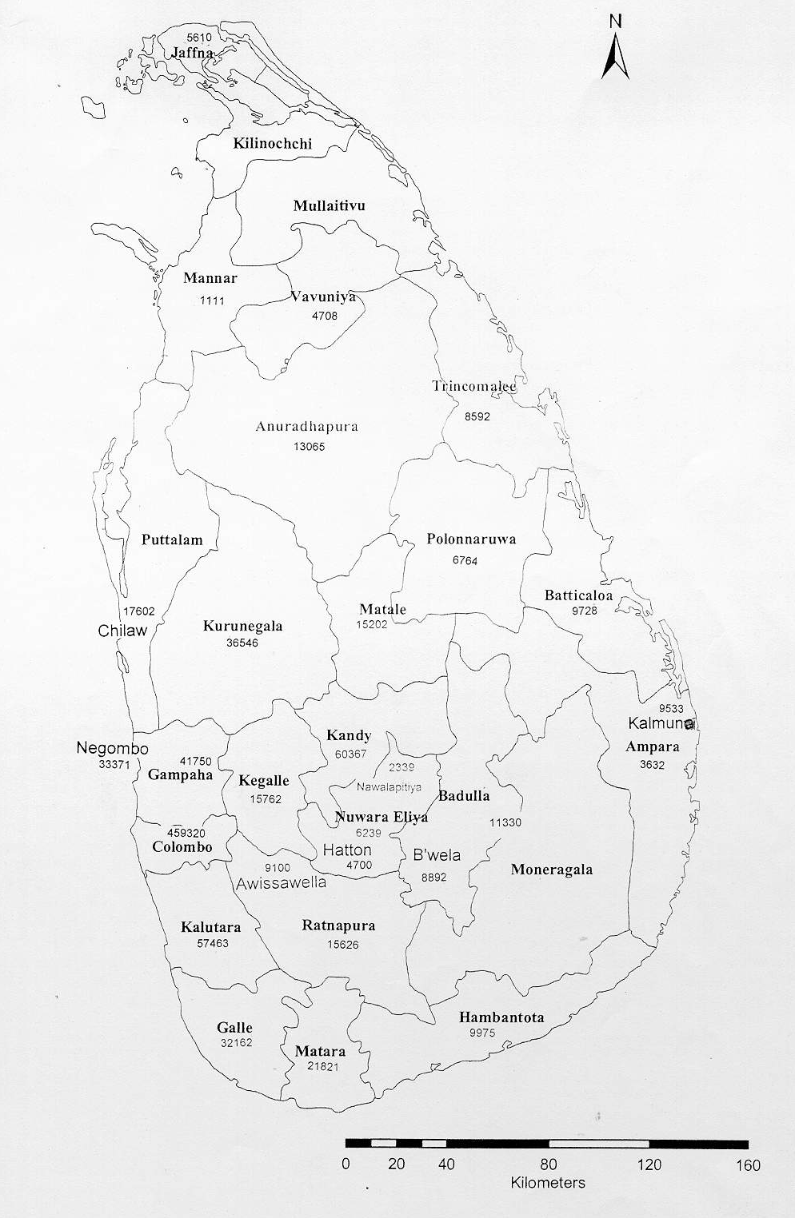
A - 26151

NCD–34189
CD –33817
NCD– 7552
CD– 11546
NCD–20570
CD– 37173
NCD-10002
CD- 36155
A-
NCD–
CD –
NCD–24833
CD– 24760
A -
NCD–24669
CD– 48625
NCD– 61846
CD– 29325
NCD-20613
CD – 66939
NCD – 517645
CD – 195385
NCD–16433
CD– 43637
NCD–14077
CD– 9674
NCD–19484
CD – 16353
NCD – 4900
CD – 19152
NCD– 12957
CD – 78466
NCD– 15504
CD– 55345
NCD–36246
CD– 60762
NCD 35077
CD – 72937
NCD–17520
CD– 36182
NCD– 23291
CD– 57110
NCD–58580
CD– 48147
NCD– 2895
CD – 6526

NCD–48456
CD – 62261
NCD–11139
CD– 11877
A - 2433
A - 6648
A - 6364
A - 2510
A - 6208
A-21917
A - 6046
A- 11039
A - 3005

A - 16206

CD – CDMA
NCD – Non CDMA
A - ADSL
A-28608

A-32176
NCD– 52778
CD – 88095
A - 27690
NCD– 7573
CD – 31345
NCD-79721
CD– 75344

A - 6764

A - 10191

A – 210810
A - 17342
A - 8583
A - 10735
A-12016
A-4228
A- 8035
A - 10649
A- 12201
A-11955
A - 6672

NCD– 6736
CD– 35422
A - 39298

NCD–22614
CD – 97037

