1. Cumulative Number of Licenses granted under Section 17 of the Sri Lanka Telecommunications Act No 25 of 1991 as amended.

Category of Service  Licensed under Section 17 of the Act. | 2016 March
- Fixed Access Telephone service | 3
- Cellular Mobile phones | 5
- Data Communications (Facility based) | 3
- Data Communications (Non-facility based) & ISP’s | 09
- Trunk Mobile Radio | 1
- External Gateway Operators | 07
- Direct-to-Home Satellite Broadcasting Service | 04
- Cable TV Distribution Network | 03
- Satellite Services | 01
- Other | 01
Sub Total | 37
SLTL, Lanka Bell, Dialog Broadband are entitled to provide Pay phone and Data services according to their licences.

  - Fixed Operators
No | Category | Operator | Date of Issue | Period | Date of Expiry
01 | Fixed Operators | Sri Lanka Telecom PLC | 09.02.2012 | Ten years (10) | 09.02.2022
02 |  | Lanka Bell Ltd. | 26.02.1996 | Twenty years (20) | 26.02.2016**
03 |  | Dialog Broadband Networks (Pvt.) Ltd. | 10.11.2005 | Ten years (10) | 10.11.2015**
** - Renewal Process in Progress

  - Mobile Operators
No | Category | Operator | Date of Issue | Period | Date of Expiry
01 | Mobile  Operators | Hutchison Telecommunications Lanka (Pvt.) Ltd. | 11.02.2012 | Ten years(10) | 11.02.2022
02 |  | Etisalat Lanka (Pvt.) Ltd. | 13.09.2008 | Ten years(10) | 13.09.2018
03 |  | Dialog Axiata PLC | 28.09.2013 | Ten years(10) | 28.09.2023
04 |  | Mobitel (Pvt.) Ltd. | 10.02.2013 | Ten years(10) | 10.02.2023
05 |  | Bharti Airtel Lanka (Pvt.) Ltd. | 12.04.2007 | Ten years(10) | 12.04.2017

  - Data Communication Operators
No | Category | Operator | Date of Issue | Period | Date of Expiry
01 | Data Communication Operators | Lanka Communication Services (Pvt.) Ltd. | 04.07.2011 | Ten years(10) | 04.07.2021
02 |  | Sky Network (Pvt.) Ltd. | 15.12.2006 | Ten years(10) | 15.12.2016
03 |  | Societe International Telecommunications Aeronautiques (SITA) | 06.08.2012 | Five years(05) | 06.08.2017

  - Internet Service Providers

No | Category | Operator | Date of Issue | Period | Date of Expiry
01 | Internet  Service  Providers | Dialog Broadband Networks (Pvt.) Ltd. | 05.12.2013 | Five years (05) | 05.12.2018
02 |  | Eureka Technology Partners (Pvt.) Ltd. | 16.08.2011 | Five years (05) | 16.08.2016
03 |  | Etisalat Lanka (Pvt.) Ltd. | 23.03.2014 | Five years (05) | 23.03.2019
04 |  | Dialog Axiata PLC. | 01.11.2011 | Five years (05) | 01.11.2016
05 |  | Mobitel (Pvt.) Ltd. | 01.02.2012 | Five years (05) | 01.02.2017
06 |  | Hutchison Tele Lanka (Pvt.) Ltd. | 01.03.2013 | Five years (05) | 01.03.2018
07 |  | TATA Communications Lanka Ltd. | 10.02.2015 | Five years (05) | 10.02.2020
08 |  | Lanka Education and Research Network | 01.09.2011 | Five years (05) | 01.09.2016
09 |  | Bharti Airtel Lanka (Pvt.) Ltd | 28.03.2014 | Five years (05) | 28.03.2019

  - Trunk Radio Operators
No | Category | Operator | Date of Issue | Period | Date of Expiry
01 | Trunk Radio Operators | Dynacom Engineering (Pvt.) Ltd | 25.02.2013 | Five years(05) | 25.02.2018

  - International Telecommunication Operators
No | Category | Operator | Date of Issue | Period | Date of Expiry
01 | International Telecommunication Operators (earlier External Gateway Operators) | Lanka Bell Ltd. | 28.02.2013 | Ten years(10) | 28.02.2023
02 |  | Dialog Axiata PLC | 28.02.2013 | Ten years (10) | 28.02.2023
03 |  | Etisalat Lanka (Pvt.) Ltd. | 28.02.2013 | Ten years (10) | 28.02.2023
04 |  | Mobitel (Pvt.) Ltd. | 07.03.2013 | Ten years(10) | 07.03.2023
05 |  | Bharti Airtel Lanka (Pvt.) Ltd. | 01.12.2007 | Ten years(10) | 01.12.2017
06 |  | TATA Communications Lanka (Pvt.) Ltd. | 06.06.2013 | Ten years (10) | 06.06.2023
07 |  | Hutchison Telecommunications Lanka (Pvt.) Ltd. | 28.02.2015 | Ten years (10) | 28.02.2025

  - Direct-to-Home Satellite Broadcasting Service
No | Category | Operator | Date of Issue | Period | Date of Expiry
01 | Direct to Home Satellite Broadcasting Operators | Future Satcom Holding (Pvt.) Ltd., | 18.10.2011 | Five years (05) | 18.10.2016
02 |  | Dialog Television (Pvt.) Ltd | 01.02.2012 | Five years(05) | 01.02.2017
03 |  | DISH TV Lanka (Pvt.) Ltd | 30.11.2013 | Three years(03) | 18.10.2016
04 |  | MTV Channel (Pvt.) Ltd., | 15.10.2015 | Five years (05) | 15.10.2020

  - Cable TV Distribution Network Operators
No | Category | Operator | Date of Issue | Period | Date of Expiry
01 | Cable Distribution Network Operators | Lanka Broadband Networks Ltd | 22.12.2011 | Five years (05) | 22.12.2016
02 |  | Lanka Cable & Satellite Network (Pvt.) Ltd | 07.06.2012 | Five years(05) | 07.06.2017
03 |  | Ask Cable Vision (Pvt.) Ltd | 01.03.2013 | Five years(05) | 01.03.2018

  - Satellite Services
No | Category | Operator | Date of Issue | Period | Date of Expiry
01 | Satellite Services | Supreme Sat (Pvt.)Ltd | 10.05.2013 | Five years (05) | 10.05.2018

  - Other Operators
No | Category | Operator | Date of Issue | Period | Date of Expiry
01 | Other Operators | Tritel Services (Pvt.)Ltd | 20.09.2010 | Five years (05) | 20.09.2015***
02 |  | Dialog Broadband Network (Pvt.) Ltd | 08.05.1995 | Twenty years(20) | 08.05.2015***

*** - Renewal process in progress

2. Statistical Overview of the Telecommunication Sector as at end of Mar 2016
Number of System Licenses | 37
Total number of Fixed phones | 2,604,222*
Teledensity (Fixed Phones per 100 inhabitants) – 2015 Dec | 12.4
Number of Cellular Mobile Subscribers (90 days) | 24,568,745*
Mobile Subscription per 100 people – 2015 Dec | 116.7
Internet & Email Subscribers – Fixed | 718,168*
Fixed Narrowband subscribers | 9,182*
Fixed Broadband subscribers | 708,986*
Internet & Email Broadband Subscribers (Mobile ) | 3,484,079*
Number of Public Pay Phone Booths | 5,705*

* - Provisional;

- Number of Fixed Access Telephone Subscribers of (1990 – 2016 Mar)

Year | 1990 | 1991 | 1992 | 1993 | 1994 | 1995 | 1996 | 1997 | 1998 | 1999 | 2000 | 2001 | 2002 | 2003 | 2004 | 2005 | 2006 | 2007 | 2008 | 2009 | 2010 | 2011 | 2012 | 2013 | 2014 | 2015 | 2016 Mar
Subscribers | 121,388 | 125,834 | 135,504 | 157,774 | 180,724 | 204,350 | 255,049 | 341,622 | 523,529 | 669,113 | 767,411 | 827,195 | 883,108 | 939,013 | 991,239 | 1,243,994 | 1,884,076 | 2,742,059 | 3,446,411 | 3,435,958 | 3,578,463 | 3,608,392 | 3,449,391 | 2,706,787 | 2,709,848 | 2,601,196 | 2,604,222

4. Mobile Subscribers (1992 – 2016 Mar)

Year | 1992 | 1993 | 1994 | 1995 | 1996 | 1997 |  | 1998 | 1999 | 2000 | 2001 | 2002 | 2003 | 2004 | 2005 | 2006 | 2007 | 2008 | 2009 | 2010 | 2011 | 2012 | 2013 | 2014 | 2015 | 2016 Mar
Subscribers | 2,644 | 14,687 | 29,182 | 51,316 | 71,029 | 114,888 | 174,202 |  | 256,655 | 430,202 | 667,662 | 931,403 | 1,393,403 | 2,211,158 | 3,361,775 | 5,412,496 | 7,983,489 | 11,082,454 | 14,264,442 | 17,267,407 | 18,319,447 | 20,324,070 | 20,447,508 | 22,123,000 | 24,384,544 | 24,568,745

Note: The definition of Active subscriber was revised in January 2013

5. Internet & Email Subscribers (Fixed & BB Mobile)
Year | Fixed | Mobile BB
1996 | 2,504
1997 | 10,195
1998 | 18,984
1999 | 25,535
2000 | 40,497
2001 | 61,532
2002 | 73,468
2003 | 85,500
2004 | 93,444
2005 | 115,000
2006 | 130,000
2007 | 202,348
2008 | 234,000
2009 | 249,756 | 91,359
2010 | 302,000 | 200,000
2011 | 359,000 | 485,000
2012 | 423,194 | 942,461
2013 | 507,845 | 1,664,003
2014 | 606,100 | 2,790,195
2015 | 682,512 | 3,408,408
2016 Mar | 718,168 | 3,484,079

Western | 2,653
Southern | 585
Central | 754
Sabaragamuwa | 342
Uva | 203
North Central | 270
North West | 581
East | 236
North | 81
Total | 5,705
6. Provincial Distribution of Payphones (March 2016)

7. Call Duration (in Minutes)

 | 2011 | 2012 | 2013 | 2014 | 2015 |  |  |  |  |  |  |  | 2016
 | Q1->Q4 | Q1->Q4 | Q1->Q4 | Q1->Q4 | Q1 |  | Q2 |  | Q3 |  | Q4 |  | Q1
Incoming Calls |  |  |  |  | Fix | Mob | Fix | Mob | Fix | Mob | Fix | Mob | Fix | Mob
Local | 37,683,542,412 | 41,578,695,297 | 41,633,469,455 | 43,435,808,621 | 921,115,931 | 9,968,647,406 | 922,381,042 | 10,289,657,748 | 927,513,911.39 | 10,471,708,052 | 907,253,705.68 | 10,348,389,944 | 830,121,701 | 10,487,248,866
International | 1,977,309,199 | 2,023,274,456 | 1,935,790,037 | 1,933,590,273.6 | 113,344,902 | 326,301,626 | 125,799,143 | 300,835,320 | 115,758,509 | 268,402,141 | 97,823,503 | 243,920,659 | 93,483,221 | 224,496,031
Outgoing Calls |  |  |  |  | Fix | Mob | Fix | Mob | Fix | Mob | Fix | Mob | Fix | Mob
 |  |  |  |  | Q1 |  | Q2 |  | Q3 |  | Q4 |  | Q1
Local | 37,248,089,885 | 41,424,867,030 | 41,043,805,496 | 43,616,401,855 | 904,877,872.49 | 9,986,315,863 | 880,756,905.98 | 10,330,874,106 | 896,776,557.86 | 1,0,501,317,054 | 896,436,985.42 | 10,360,627,902 | 878,810,530 | 10,487,992,905
International | 694,065,674 | 711,226,467 | 687,196,312 | 656,391,458 | 27,166,491 | 125,775,956 | 27,048,782 | 121,340,980 | 29,715,802.40 | 113,939,044 | 26,439,932 | 104,415,601 | 26,532,938 | 96,193,868
 |  |  |  |  | e

8. No. of Employment in Telecommunication Sector

Category of Service | 1997 | 1998 | 1999 | 2000 | 2001 | 2002 | 2003 | 2004 | 2005 | 2006 | 2007 | 2008 | 2009 | 2010 | 2011 | 2012 | 2013 | 2014 | 2015 | 2016*
Fixed Access Telephony – SLTL | 8,793 | 8,648 | 8,802 | 9,126 | 8,681 | 8,411 | 7,303 | 7,211 | 7,295 | 7,172 | 7,033 | 6,983 | 6,557 | 6,297 | 6150 | 6,061 | 5905 | 5824 | 5,805 | 5,747
- WLL (Suntel [+DBN+LBell) + DDialog Broadband?) | 476 | 814 | 740 | 783 | 810 | 822 | 833 | 814 | 1,053 | 2,154 | 2,852 | 2,532 | 2,388 | 2275 | 1,995 | 1,524 | 1459 | 1407 | 1,383# | 1,379#
Cellular | 425 | 552 | 852 | 1,016 | 1,124 | 1,063 | 1,699 | 2,207 | 2,360 | 3,525 | 4,985 | 5,716 | 4,969 | 4,595 | 4353 | 4,559 | 4744 | 4714 | 5,037 | 5,051
Other | 591 | 683 | 735 | 798 | 831 | 597 | 553 | 581 | 537 | 574 | 574 | 574 | 574 | 574 | 574 | 574 | 574 | 574 | 574 | 574
Total | 10,285 | 10,697 | 11,129 | 11,386 | 11,446 | 10,893 | 10,388 | 10,813 | 11,245 | 13,425 | 15,444 | 15,805 | 14,488 | 13,741 | 12,982 | 12,718 | 12,682 | 12,519 | 12,799* | 12,751*

*-Provisional
# - Lanka bell data not updated

*. – Provisional Note: SSC (Secondary Switching Centre)

09. Provincial Distribution of Fixed Phones in Sri Lanka as at 2016 March (SSC Area wise Distribution)
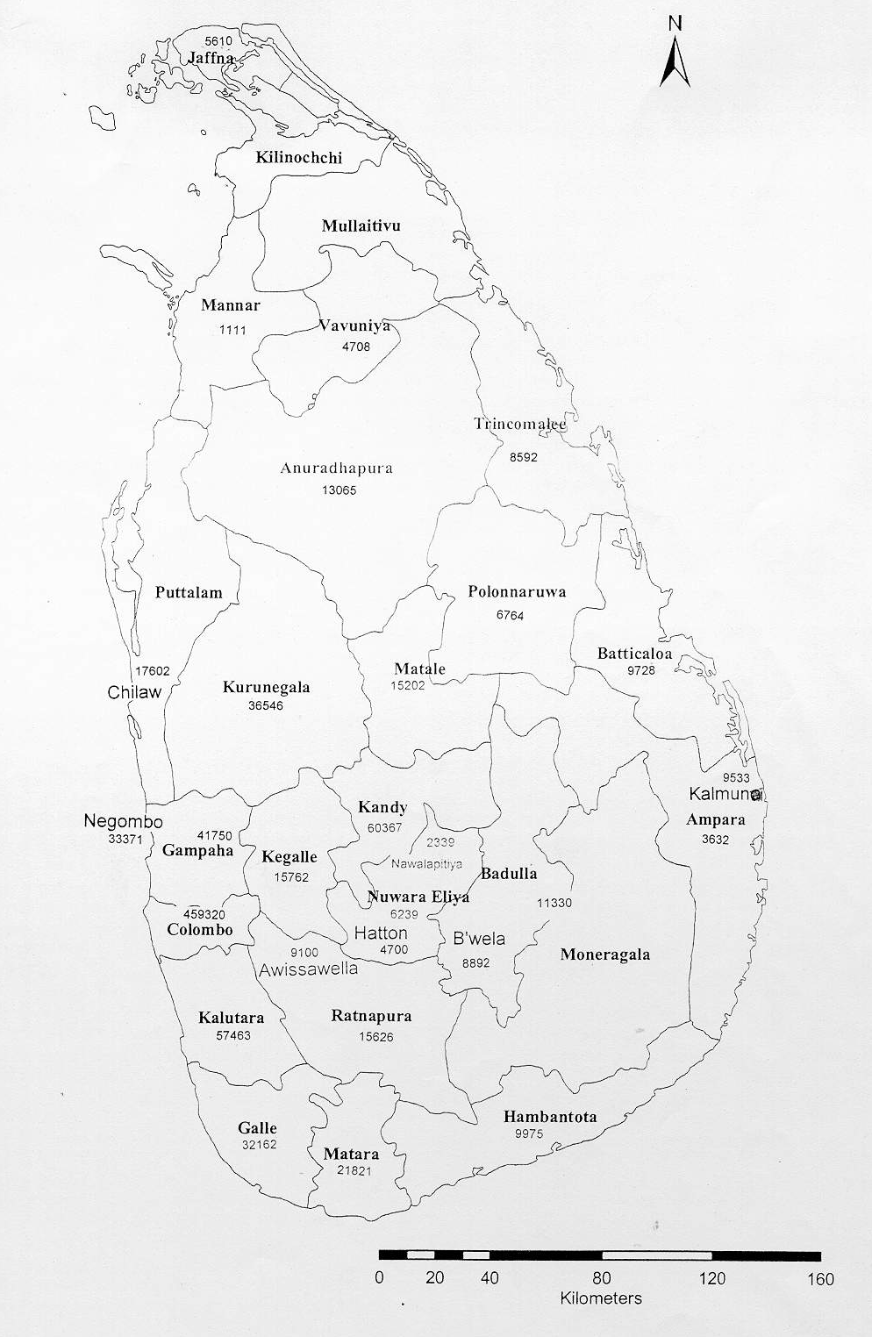
A - 24668

A - 9840
NCD–32856
CD –31105
NCD– 7305
CD– 13246
NCD–20147
CD– 37859
NCD-9585
CD- 110148
A-
NCD–
CD –89414
NCD–24372
CD– 24459
A -
NCD–23786
CD– 49350
NCD– 60607
CD– 29747
NCD-19830
CD – 61250
NCD – 479430
CD – 195826
NCD–21444
CD – 45690
NCD–16089
CD– 44006
NCD–13791
CD– 11145
NCD–19072
CD –14769
NCD – 4767
CD – 10682
NCD– 12388
CD – 79622
NCD– 14730
CD– 56264
NCD–34768
CD– 61554
NCD 33094
CD – 74255
NCD–16872
CD– 36534
NCD– 22357
CD– 58314
NCD–57296
CD– 48360
NCD– 2911
CD – 18534
A-3850

A-10640
NCD–47609
CD – 93282
A - 8072
NCD–11097
CD– 26696
A - 2289
A - 5998
A - 5994
A - 6003
A-10655
A - 2097
A - 5431
A- 11111
A - 9120
A-20577
A- 7094
A - 5673
A- 10457
A - 2832

A - 10083
A - 6219

A - 15477

CD – CDMA
NCD – Non CDMA
A - ADSL
A - 16477
A - 37391

A-26779

A-31204
NCD– 51207
CD – 89567
A - 26817
A - 207866
NCD– 6517
CD– 36025
NCD– 7306
CD – 31270
NCD-77609
CD– 75498

