1. Cumulative Number of Licenses granted under Section 17 of the Sri Lanka Telecommunications Act No 25 of 1991 as amended.

Category of Service  Licensed under Section 17 of the Act. | 2015 Mar
Fixed Access Telephone service | 3
Cellular Mobile phones | 5
Data Communications (Facility based) | 5
Data Communications (Non-facility based) & ISP’s | 10
Trunk Mobile Radio | 1
Leased Circuit Providers | 1
Licensed Payphone Service Providers | 1
External Gateway Operators | 06
Direct-to-Home Satellite Broadcasting Service | 03
Cable TV Distribution Network | 03
Satellite Services | 01
Sub Total | 39
SLTL, Lanka Bell, Dialog Broadband are entitled to provide Pay phone and Data services according to their licences.

2. Statistical Overview of the Telecommunication Sector as at end of Mar 2015
Number of System Licenses | 39
Total number of Fixed phones | 2,709,551
Teledensity (Fixed Phones per 100 inhabitants) | 13
Number of Cellular Mobile Subscribers (90 days) | 22,720,142
Mobile Subscription per 100 people | 108
Internet & Email Subscribers – Fixed | 599,810*
Fixed Narrowband subscribers | 23,904
Fixed Broadband subscribers | 575,906
Internet & Email Broadband Subscribers (Mobile ) | 2,986,665**
Number of Public Pay Phone Booths | 6,275*

* - Provisional
** - Definition has been changed

3. Performance of Fixed Access Telephone Subscribers as at Mar 2015

Year | 1990 | 1991 | 1992 | 1993 | 1994 | 1995 | 1996 | 1997 | 1998 | 1999 | 2000 | 2001 | 2002 | 2003 | 2004 | 2005 | 2006 | 2007 | 2008 | 2009 | 2010 | 2011 | 2012 | 2013 | 2014 | 2015 Mar
Subscribers | 121,388 | 125,834 | 135,504 | 157,774 | 180,724 | 204,350 | 255,049 | 341,622 | 523,529 | 669,113 | 767,411 | 827,195 | 883,108 | 939,013 | 991,239 | 1,243,994 | 1,884,076 | 2,742,059 | 3,446,411 | 3,435,958 | 3,578,463 | 3,608,392 | 3,449,391 | 2,706,787 | 2,709,848 | 2,709,551

4. Mobile Subscribers (1992 – 2015 Mar)

Year | 1992 | 1993 | 1994 | 1995 | 1996 | 1997 |  | 1998 | 1999 | 2000 | 2001 | 2002 | 2003 | 2004 | 2005 | 2006 | 2007 | 2008 | 2009 | 2010 | 2011 | 2012 | 2013 | 2014 | 2015 Mar
Subscribers | 2,644 | 14,687 | 29,182 | 51,316 | 71,029 | 114,888 | 174,202 |  | 256,655 | 430,202 | 667,662 | 931,403 | 1,393,403 | 2,211,158 | 3,361,775 | 5,412,496 | 7,983,489 | 11,082,454 | 14,264,442 | 17,267,407 | 18,319,447 | 20,324,070 | 20,447,508 | 22,123,000 | 22,720,142*

Note: The definition of Active subscriber was revised in January 2013

5. Internet & Email Subscribers (Fixed & BB Mobile)

Year | Fixed | Mobile BB
1996 | 2,504
1997 | 10,195
1998 | 18,984
1999 | 25,535
2000 | 40,497
2001 | 61,532
2002 | 73,468
2003 | 85,500
2004 | 93,444
2005 | 115,000
2006 | 130,000
2007 | 202,348
2008 | 234,000
2009 | 249,756 | 91,359
2010 | 302,000 | 200,000
2011 | 359,000 | 485,000
2012 | 423,194 | 942,461
2013 | 507,845 | 1,664,003
2014 | 606,100 | 2,802,881
2015 Mar | 599,810* | 2,986,665*

Western | 2,934
Southern | 669
Central | 805
Sabaragamuwa | 371
Uva | 220
North Central | 294
North West | 626
East | 270
North | 86
Total | 6,275
6. Provincial Distribution of Payphones (Mar 2015)

7. Call Duration (In minutes)
 | 2011 |  |  |  |  |  |  | 2012 |  |  |  |  |  |  |  | 2013 |  |  |  | 2014 |  |  |  |  |  | 2015
 | Q1 | Q2 |  | Q3 |  | Q4 |  | Q1 |  | Q2 |  | Q3 |  | Q4 |  | Q1 | Q2 | Q3 | Q4 | Q1 | Q2 |  | Q3 | Q4 |  | Q1
Incoming Calls
Local | 8,885,560,796 | 9,278,005,357 | 9,711,571,048 |  | 9,808,405,211 |  | 10,182,583,993 |  | 10,239,486,074 |  | 10,641,734,863 |  | 10,514,890,367 |  | 10,881,678,190 |  | 10,412,722,919 | 10,776,567,168 | 9,562,501,178 | 10,660,684,740 | 10,764,787,406 |  | 11,083,941,523 | F –926,483,695 | M - 9,999,911,257 | F – 921,115,931 (e) | M – 9,968,647,406
International | 481,289,292 | 495,518,656 | 523,739,239 |  | 476,762,012 |  | 493,231,675 |  | 488,145,802 |  | 496,405,338 |  | 545,491,641 |  | 517,577,549 |  | 476,844,498 | 504,719,629 | 436,648,361 | 481,286,544.6 | 497,280,694 |  | 492,429,508 | F –125,965,531 | M – 336,627,996 | F – 113,344,902 (e) | M – 264,068,168.2
Outgoing Calls
Local | 8,537,531,495 | 9,197,141,590 | 9,756,732,968 |  | 9,756,683,832 |  | 10,085,613,377 |  | 10,191,979,189 |  | 10,658,090,975 |  | 10,489,183,489 |  | 10,345,226,364 |  | 10,271,312,622 | 10,855,726,781 | 9,571,539,729 | 10,659,215,017 | 10,819,789,489 |  | 11,169,525,246 | F - 949,135,254 | M – 10,018,736,849 | F – 904,877,872 (e) M – 10,018,736,849 | M – 9,986,315,863 M – 10,018,736,849
International | 169,612,460 | 172,325,661 | 175,099,111 |  | 177,028,442 |  | 174,164,782 |  | 175,234,314 |  | 182,371,931 |  | 179,455,440 |  | 165,214,597 |  | 178,509,175 | 179,836,244 | 163,636,296 | 173,801,739.6 | 172,244,287.3 |  | 146,479,278 | F - 31,572,875 | M – 132,293,278 | F - 27,166,491 (e) | M – 102,541,224.8 (e)

F – Fixed , M – Mobile, e - Estimated

8. Employment Opportunities in Telecommunication Sector

Category of Service | 1997 | 1998 | 1999 | 2000 | 2001 | 2002 | 2003 | 2004 | 2005 | 2006 | 2007 | 2008 | 2009 | 2010 | 2011 | 2012 | 2013 | 2014
Fixed Access Telephony – SLTL | 8,793 | 8,648 | 8,802 | 9,126 | 8,681 | 8,411 | 7,303 | 7,211 | 7,295 | 7,172 | 7,033 | 6,983 | 6,557 | 6,297 | 6150 | 6,061 | 5905 | 5824
- WLL (Suntel [+DBN+LBell) + DDialog Broadband?) | 476 | 814 | 740 | 783 | 810 | 822 | 833 | 814 | 1,053 | 2,154 | 2,852 | 2,532 | 2,388 | 2275 | 1,995 | 1,524 | 1459 | 1407
Cellular | 425 | 552 | 852 | 1,016 | 1,124 | 1,063 | 1,699 | 2,207 | 2,360 | 3,525 | 4,985 | 5,716 | 4,969 | 4,595 | 4353 | 4,559 | 4744 | 4714
Radio Paging | 190 | 185 | 148 | 108 | 57 | 30 | 32 | 21 | N/A | N/A | N/A | N/A | N/A | N/A | N/A | N/A | N/A | N/A
DATA Communication | 285 | 318 | 337 | 337 | 437 | 277 | 285 | 285 | 242 | 275 | 275 | 275 | 275 | 275 | 275 | 275 | 275 | 275*
Public  Payphones | 116 | 180 | 250 | 353 | 337 | 290 | 236 | 275 | 295 | 299 | 299 | 299 | 299 | 299 | 299 | 299 | 299 | 299*
Total | 10,285 | 10,697 | 11,129 | 11,386 | 11,446 | 10,893 | 10,388 | 10,813 | 11,245 | 13,425 | 15,444 | 15,805 | 14,488 | 13,741 | 12,982 | 12,718 | 12,682 | 12,519

*– Provisional Note: SSC (Secondary Switching Centre)

09. Provincial Distribution of Fixed Phones in Sri Lanka as at 2014 Dec (SSC Area wise Distribution)

A - 19215

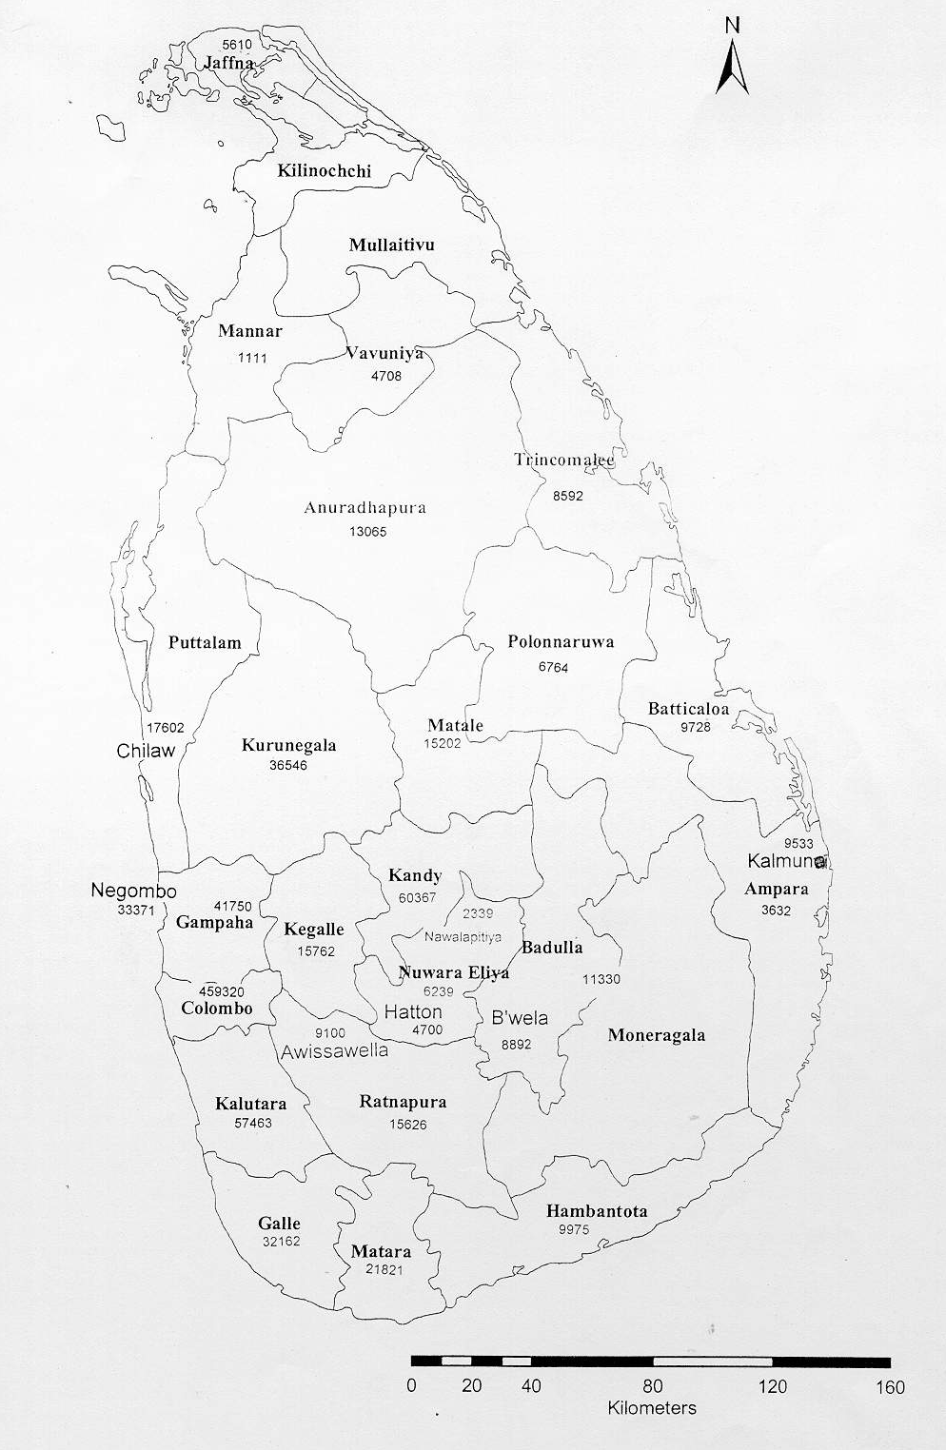
A - 8355
NCD–28036
CD –40228
NCD– 7397
CD– 14675
NCD–20161
CD– 42359
NCD-21337
CD- 38095
A-
NCD– 58?
CD –33600?
NCD–24084
CD– 24335
A -
NCD–22898
CD– 53549
NCD– 60057
CD– 31193
NCD-18552
CD – 78034
NCD – 480290
CD – 193456
NCD–47498
CD –134808
NCD–15038
CD– 46037
NCD–14320
CD– 11371
NCD–18850
CD – 18620
NCD – 4369
CD – 20589
NCD– 12245
CD – 83053
NCD– 15394
CD– 61450
NCD–34682
CD– 66785
NCD 31061
CD – 80852
NCD–15725
CD– 39188
NCD– 21374
CD– 65821
NCD–56544
CD– 55324
NCD–9146
CD –40387
NCD– 2931
CD – 7771
A-3149

A - 6686
NCD–10499
CD– 13606
A - 1457
A - 4956
A - 5169
A - 5831
A - 9734
A - 1718
A - 8762
A -18981
A - 6824
A -3674
A- 5500
A - 4739
A - 9416
A - 2549

A - 8804
A10436
A - 5663

A - 15222

CD – CDMA
NCD – Non CDMA
A - ADSL
A - 14405
A - 33460

A-24273

A-29177
NCD– 50735
CD – 98190
A - 25074
A - 197513
NCD– 6522
CD– 38114
NCD– 7382
CD – 31625
NCD-75008
CD– 81827

