1. Cumulative Number of Licenses granted under Section 17 of the Sri Lanka Telecommunications Act No 25 of 1991 as amended.

Category of Service  Licensed under Section 17 of the Act. | 2015 Sep
- Fixed Access Telephone service | 3
- Cellular Mobile phones | 5
- Data Communications (Facility based) | 4
- Data Communications (Non-facility based) & ISP’s | 09
- Trunk Mobile Radio | 1
- External Gateway Operators | 07
- Direct-to-Home Satellite Broadcasting Service | 03
- Cable TV Distribution Network | 03
- Satellite Services | 01
- Leased Circuit Providers | 01
- Licensed Payphone Service Providers | 01
Sub Total | 38
SLTL, Lanka Bell, Dialog Broadband are entitled to provide Pay phone and Data services according to their licences.

  - Fixed Operators
No | Category | Operator | Date of Issue | Period | Date of Expiry
01 | Fixed Operators | Sri Lanka Telecom PLC | 09.02.2012 | Ten years (10) | 09.02.2022
02 |  | Lanka Bell Ltd. | 26.02.1996 | Twenty years (20) | 26.02.2016
03 |  | Dialog Broadband Networks (Pvt.) Ltd. | 10.11.2005 | Ten years (10) | 10.11.2015

  - Mobile Operators
No | Category | Operator | Date of Issue | Period | Date of Expiry
01 | Mobile  Operators | Hutchison Telecommunications Lanka (Pvt.) Ltd. | 11.02.2012 | Ten years(10) | 11.02.2022
02 |  | Etisalat Lanka (Pvt.) Ltd. | 13.09.2008 | Ten years(10) | 13.09.2018
03 |  | Dialog Axiata PLC | 28.09.2013 | Ten years(10) | 28.09.2023
04 |  | Mobitel (Pvt.) Ltd. | 10.02.2013 | Ten years(10) | 10.02.2023
05 |  | Bharti Airtel Lanka (Pvt.) Ltd. | 12.04.2007 | Ten years(10) | 12.04.2017

  - Data Communication Operators
No | Category | Operator | Date of Issue | Period | Date of Expiry
01 | Data Communication Operators | Lanka Communication Services (Pvt.) Ltd. | 04.07.2011 | Ten years(10) | 04.07.2021
02 |  | Ceycom Global Communications Ltd. | 19.09.1995 | Twenty years(20) | 19.09.2015
03 |  | Sky Network (Pvt.) Ltd. | 15.12.2006 | Ten years(10) | 15.12.2016
04 |  | Societe International Telecommunications Aeronautiques (SITA) | 06.12.2012 | Five years(05) | 06.12.2017

  - Internet Service Providers

No | Category | Operator | Date of Issue | Period | Date of Expiry
01 | Internet  Service  Providers | Dialog Broadband Networks (Pvt.) Ltd. | 04.12.2013 | Five years (05) | 04.12.2018
02 |  | Eureka Technology Partners (Pvt.) Ltd. | 16.08.2011 | Five years (05) | 16.08.2016
03 |  | Etisalat Lanka (Pvt.) Ltd. | 23.03.2014 | Five years (05) | 23.03.2019
04 |  | Dialog Axiata PLC. | 30.12.2014 | Five years (05) | 30.12.2019
05 |  | Mobitel (Pvt.) Ltd. | 01.02.2012 | Five years (05) | 01.02.2017
06 |  | Hutchison Tele Lanka (Pvt.) Ltd. | 29.02.2013 | Five years (05) | 29.02.2018
07 |  | TATA Communications Lanka Ltd. | 10.02.2015 | Five years (05) | 10.02.2020
08 |  | Lanka Education and Research Network | 01.09.2011 | Five years (05) | 01.09.2016
09 |  | Bharti Airtel Lanka (Pvt.) Ltd | 28.03.2014 | Five years (05) | 28.03.2019

  - Trunk Radio Operators
No | Category | Operator | Date of Issue | Period | Date of Expiry
01 | Trunk Radio Operators | Dynacom Engineering (Pvt.) Ltd | 25.02.2013 | Five years(05) | 25.02.2018

  - International Telecommunication Operators
No | Category | Operator | Date of Issue | Period | Date of Expiry
01 | International Telecommunication Operators (earlier External Gateway Operators) | Lanka Bell Ltd. | 28.02.2013 | Ten years(10) | 28.02.2023
02 |  | Dialog Axiata PLC | 28.02.2013 | Ten years (10) | 28.02.2023
03 |  | Etisalat Lanka (Pvt.) Ltd. | 28.02.2013 | Ten years (10) | 28.02.2023
04 |  | Mobitel (Pvt.) Ltd. | 07.03.2013 | Ten years(10) | 07.03.2023
05 |  | Bharti Airtel Lanka (Pvt.) Ltd. | 01.12.2007 | Ten years(10) | 01.12.2017
06 |  | TATA Communications Lanka (Pvt.) Ltd. | 06.06.2013 | Ten years (10) | 06.06.2023
07 |  | Hutchison Telecommunications Lanka (Pvt.) Ltd. | 28.02.2015 | Ten years (10) | 28.02.2025

  - Direct-to-Home Satellite Broadcasting Service
No | Category | Operator | Date of Issue | Period | Date of Expiry
01 | Direct to Home Satellite Broadcasting Operators | Future Satcom Holding (Pvt.) Ltd., | 18.10.2011 | Five years (05) | 18.10.2016
02 |  | Dialog Television (Pvt.) Ltd | 01.02.2012 | Five years(05) | 01.02.2017
03 |  | DISH TV Lanka (Pvt.) Ltd | 30.11.2013 | Three years(03) | 18.10.2016

  - Cable TV Distribution Network Operators
No | Category | Operator | Date of Issue | Period | Date of Expiry
01 | Cable Distribution Network Operators | Lanka Broadband Networks Ltd | 22.12.2011 | Five years (05) | 22.12.2016
02 |  | Lanka Cable & Satellite Network (Pvt.) Ltd | 07.06.2012 | Five years(05) | 07.06.2017
03 |  | Ask Cable Vision (Pvt.) Ltd | 01.03.2013 | Five years(05) | 01.03.2018

  - Satellite Services
No | Category | Operator | Date of Issue | Period | Date of Expiry
01 | Satellite Services | Suprem Sat (Pvt.)Ltd | 10.05.2013 | Five years (05) | 10.05.2018

  - Other Operators
No | Category | Operator | Date of Issue | Period | Date of Expiry
01 | Other Operators | Tritel Services (Pvt.)Ltd | 21.09.2010 | Five years (05) | 21.09.2015***
02 |  | Dialog Broadband Network (Pvt.) Ltd | 08.05.1995 | Twenty years(20) | 08.05.2015***

*** - Renewal process in progress

2. Statistical Overview of the Telecommunication Sector as at end of Sep 2015
Number of System Licenses | 38
Total number of Fixed phones | 2,644,366
Teledensity (Fixed Phones per 100 inhabitants) | 12.6
Number of Cellular Mobile Subscribers (90 days) | 23,771,580
Mobile Subscription per 100 people | 113.4
Internet & Email Subscribers – Fixed | 631,523*
Fixed Narrowband subscribers | 16,417*
Fixed Broadband subscribers | 615,106*
Internet & Email Broadband Subscribers (Mobile ) | 3,373,388**
Number of Public Pay Phone Booths | 5,955*

* - Provisional; ** - Definition has been changed

3. Performance of Fixed Access Telephone Subscribers as at Sep 2015

Year | 1990 | 1991 | 1992 | 1993 | 1994 | 1995 | 1996 | 1997 | 1998 | 1999 | 2000 | 2001 | 2002 | 2003 | 2004 | 2005 | 2006 | 2007 | 2008 | 2009 | 2010 | 2011 | 2012 | 2013 | 2014 | 2015 Sep
Subscribers | 121,388 | 125,834 | 135,504 | 157,774 | 180,724 | 204,350 | 255,049 | 341,622 | 523,529 | 669,113 | 767,411 | 827,195 | 883,108 | 939,013 | 991,239 | 1,243,994 | 1,884,076 | 2,742,059 | 3,446,411 | 3,435,958 | 3,578,463 | 3,608,392 | 3,449,391 | 2,706,787 | 2,709,848 | 2,644,366

4. Mobile Subscribers (1992 – 2015 Sep)

Year | 1992 | 1993 | 1994 | 1995 | 1996 | 1997 |  | 1998 | 1999 | 2000 | 2001 | 2002 | 2003 | 2004 | 2005 | 2006 | 2007 | 2008 | 2009 | 2010 | 2011 | 2012 | 2013 | 2014 | 2015 Sep
Subscribers | 2,644 | 14,687 | 29,182 | 51,316 | 71,029 | 114,888 | 174,202 |  | 256,655 | 430,202 | 667,662 | 931,403 | 1,393,403 | 2,211,158 | 3,361,775 | 5,412,496 | 7,983,489 | 11,082,454 | 14,264,442 | 17,267,407 | 18,319,447 | 20,324,070 | 20,447,508 | 22,123,000 | 23,771,580

Note: The definition of Active subscriber was revised in January 2013

5. Internet & Email Subscribers (Fixed & BB Mobile)
Year | Fixed | Mobile BB
1996 | 2,504
1997 | 10,195
1998 | 18,984
1999 | 25,535
2000 | 40,497
2001 | 61,532
2002 | 73,468
2003 | 85,500
2004 | 93,444
2005 | 115,000
2006 | 130,000
2007 | 202,348
2008 | 234,000
2009 | 249,756 | 91,359
2010 | 302,000 | 200,000
2011 | 359,000 | 485,000
2012 | 423,194 | 942,461
2013 | 507,845 | 1,664,003
2014 | 606,100 | 2,790,195
2015 Sep | 631,523 | 3,373,388

Western | 2,756
Southern | 636
Central | 782
Sabaragamuwa | 355
Uva | 211
North Central | 282
North West | 607
East | 243
North | 83
Total | 5,955
6. Provincial Distribution of Payphones (Sep 2015)

7. Call Duration (In minutes)

 | 2011 |  |  |  |  |  |  | 2012 |  |  |  |  |  |  | 2013 |  |  |  | 2014 |  |  |  |  | 2015
 | Q1 | Q2 |  | Q3 |  | Q4 |  | Q1 |  | Q2 |  | Q3 |  | Q4 | Q1 | Q2 | Q3 | Q4 | Q1 | Q2 | Q3 | Q4 |  | Q1 |  | Q2 |  |  | Q3
Incoming Calls
Local | 8,885,560,796 | 9,278,005,357 | 9,711,571,048 |  | 9,808,405,211 |  | 10,182,583,993 |  | 10,239,486,074 |  | 10,641,734,863 |  | 10,514,890,367 |  | 10,881,678,190 | 10,412,722,919 | 10,776,567,168 | 9,562,501,178 | 10,660,684,740 | 10,764,787,406 | 11,083,941,523 | F –926,483,695 | M - 9,999,911,257 | F – 921,115,931 (e) | M – 9,968,647,406 | F – 922,381,042 (e) |  | M – 10,289,657,748 | F – 925,555,739.39 | M – 10,471,708,052
International | 481,289,292 | 495,518,656 | 523,739,239 |  | 476,762,012 |  | 493,231,675 |  | 488,145,802 |  | 496,405,338 |  | 545,491,641 |  | 517,577,549 | 476,844,498 | 504,719,629 | 436,648,361 | 481,286,544.6 | 497,280,694 | 492,429,508 | F –125,965,531 | M – 336,627,996 | F – 113,344,902 (e) | M – 264,068,168.2 | F – 125,799,143 (e) |  | M – 254,582,577.2 | F – 114,436,365 | M – 232,943,762.4
Outgoing Calls
Local | 8,537,531,495 | 9,197,141,590 | 9,756,732,968 |  | 9,756,683,832 |  | 10,085,613,377 |  | 10,191,979,189 |  | 10,658,090,975 |  | 10,489,183,489 |  | 10,345,226,364 | 10,271,312,622 | 10,855,726,781 | 9,571,539,729 | 10,659,215,017 | 10,819,789,489 | 11,169,525,246 | F - 949,135,254 | M – 10,018,736,849 | F - 927,430,755 | M – 9,986,315,863 | F – 902,323,111.55 |  | M – 10,330,874,106 | F – 916,817,385.74 | M – 10,501,317,054
International | 169,612,460 | 172,325,661 | 175,099,111 |  | 177,028,442 |  | 174,164,782 |  | 175,234,314 |  | 182,371,931 |  | 179,455,440 |  | 165,214,597 | 178,509,175 | 179,836,244 | 163,636,296 | 173,801,739.6 | 172,244,287.3 | 146,479,278 | F - 31,572,875 | M – 132,293,278 | F – 27,166,491 (e) | M – 102,541,224.8 (e) | F - 27,048,782 (e) |  | M – 100,688,007.1 (e) | F - 26,383,190.4 | M – 96,228,283
M- Mobile, F- Fixed, (e) – estimated

8. Employment Opportunities in Telecommunication Sector

Category of Service | 1997 | 1998 | 1999 | 2000 | 2001 | 2002 | 2003 | 2004 | 2005 | 2006 | 2007 | 2008 | 2009 | 2010 | 2011 | 2012 | 2013 | 2014 | 2015  June*
Fixed Access Telephony – SLTL | 8,793 | 8,648 | 8,802 | 9,126 | 8,681 | 8,411 | 7,303 | 7,211 | 7,295 | 7,172 | 7,033 | 6,983 | 6,557 | 6,297 | 6150 | 6,061 | 5905 | 5824 | 5,770
- WLL (Suntel [+DBN+LBell) + DDialog Broadband?) | 476 | 814 | 740 | 783 | 810 | 822 | 833 | 814 | 1,053 | 2,154 | 2,852 | 2,532 | 2,388 | 2275 | 1,995 | 1,524 | 1459 | 1407 | 1,397#
Cellular | 425 | 552 | 852 | 1,016 | 1,124 | 1,063 | 1,699 | 2,207 | 2,360 | 3,525 | 4,985 | 5,716 | 4,969 | 4,595 | 4353 | 4,559 | 4744 | 4714 | 4,974
Radio Paging | 190 | 185 | 148 | 108 | 57 | 30 | 32 | 21 | N/A | N/A | N/A | N/A | N/A | N/A | N/A | N/A | N/A | N/A | N/A
DATA Communication | 285 | 318 | 337 | 337 | 437 | 277 | 285 | 285 | 242 | 275 | 275 | 275 | 275 | 275 | 275 | 275 | 275 | 275 | 275*
Public  Payphones | 116 | 180 | 250 | 353 | 337 | 290 | 236 | 275 | 295 | 299 | 299 | 299 | 299 | 299 | 299 | 299 | 299 | 299 | 299*
Total | 10,285 | 10,697 | 11,129 | 11,386 | 11,446 | 10,893 | 10,388 | 10,813 | 11,245 | 13,425 | 15,444 | 15,805 | 14,488 | 13,741 | 12,982 | 12,718 | 12,682 | 12,519 | 12,715*

*-Provisional
# - Lanka bell data not updated

*. – Provisional Note: SSC (Secondary Switching Centre)

09. Provincial Distribution of Fixed Phones in Sri Lanka as at 2015 June (SSC Area wise Distribution)

A - 20734

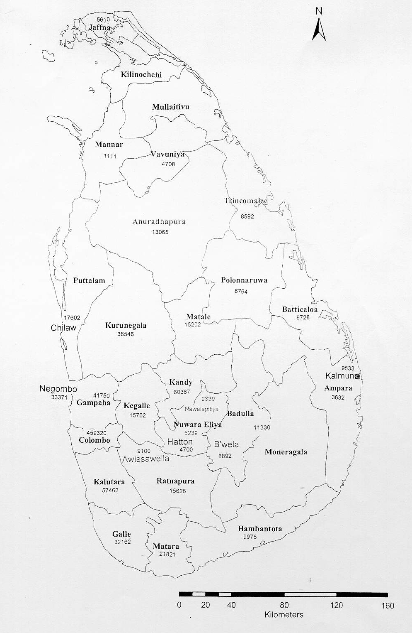
A - 8878
NCD–29912
CD –32886
NCD– 7597
CD– 14956
NCD–19927
CD– 40273
NCD-9462
CD- 116038
A-
NCD– 2
CD –92166
NCD–24152
CD– 24271
A -
NCD–23323
CD– 51425
NCD– 59919
CD– 29747
NCD-19383
CD – 65044
NCD – 478770
CD – 189868
NCD–21159
CD – 47272
NCD–15225
CD– 45062
NCD–14060
CD– 12351
NCD–19036
CD –15994
NCD – 4578
CD – 11704
NCD– 12273
CD – 81886
NCD– 14844
CD– 61471
NCD–34408
CD– 64583
NCD 31400
CD – 76836
NCD–16038
CD– 37762
NCD– 21719
CD– 62745
NCD–56925
CD– 52865
NCD– 2799
CD – 20639
A-3175

A-10640
NCD–47680
CD – 96861
A - 6848
NCD–11006
CD– 28820
A - 1428
A - 5068
A - 5430
A - 5898
A - 9759
A - 1859
A - 3915
A - 9151
A - 7504
A-19528
A- 5855
A - 4976
A - 9710
A - 2617

A - 9079
A - 5775

A - 15021

CD – CDMA
NCD – Non CDMA
A - ADSL
A - 14750
A - 34083

A-24919

A-29488
NCD– 50577
CD – 93414
A - 25152
A - 199492
NCD– 6312
CD– 37153
NCD– 7258
CD – 30597
NCD-74953
CD– 78540

