1. Cumulative Number of Licenses granted under Section 17 of the Sri Lanka Telecommunications Act No 25 of 1991 as amended.

Category of Service  Licensed under Section 17 of the Act. | 2014 Dec
Fixed Access Telephone service | 3
Cellular Mobile phones | 5
Data Communications (Facility based) | 5
Data Communications (Non-facility based) & ISP’s | 10
Trunk Mobile Radio | 1
Leased Circuit Providers | 1
Licensed Payphone Service Providers | 1
External Gateway Operators | 06
Direct-to-Home Satellite Broadcasting Service | 03
Cable TV Distribution Network | 03
Satellite Services | 01
Sub Total | 39
SLTL, Lanka Bell, Dialog Broadband are entitled to provide Pay phone and Data services according to their licences.

2. Statistical Overview of the Telecommunication Sector as at end of Dec 2014
Number of System Licenses | 39
Total number of Fixed phones | 2,709,848
Teledensity (Fixed Phones per 100 inhabitants) | 13.0
Number of Cellular Mobile Subscribers (90 days) | 22,123,000
Mobile Subscription per 100 people | 107
Internet & Email Subscribers – Fixed | 606,100
Fixed Narrowband subscribers | 38,499
Fixed Broadband subscribers | 567,601
Internet & Email Broadband Subscribers (Mobile ) | 2,802,881**
Number of Public Pay Phone Booths | 6642

* - Provisional
** - Definition has been changed

3. Performance of Fixed Access Telephone Subscribers as at Dec 2014

Year | 1990 | 1991 | 1992 | 1993 | 1994 | 1995 | 1996 | 1997 | 1998 | 1999 | 2000 | 2001 | 2002 | 2003 | 2004 | 2005 | 2006 | 2007 | 2008 | 2009 | 2010 | 2011 | 2012 | 2013 | 2014
Subscribers | 121,388 | 125,834 | 135,504 | 157,774 | 180,724 | 204,350 | 255,049 | 341,622 | 523,529 | 669,113 | 767,411 | 827,195 | 883,108 | 939,013 | 991,239 | 1,243,994 | 1,884,076 | 2,742,059 | 3,446,411 | 3,435,958 | 3,578,463 | 3,608,392 | 3,449,391 | 2,706,787 | 2,709,848

4. Mobile Subscribers (1992 – 2014 Dec)

Year | 1992 | 1993 | 1994 | 1995 | 1996 | 1997 |  | 1998 | 1999 | 2000 | 2001 | 2002 | 2003 | 2004 | 2005 | 2006 | 2007 | 2008 | 2009 | 2010 | 2011 | 2012 | 2013 | 2014 Dec
Subscribers | 2,644 | 14,687 | 29,182 | 51,316 | 71,029 | 114,888 | 174,202 |  | 256,655 | 430,202 | 667,662 | 931,403 | 1,393,403 | 2,211,158 | 3,361,775 | 5,412,496 | 7,983,489 | 11,082,454 | 14,264,442 | 17,267,407 | 18,319,447 | 20,324,070 | 20,315,150 | 22,123,000

Note: The definition of Active subscriber was revised in January 2013

5. Internet & Email Subscribers (Fixed & BB Mobile)
Year | Fixed | Mobile BB
1996 | 2,504
1997 | 10,195
1998 | 18,984
1999 | 25,535
2000 | 40,497
2001 | 61,532
2002 | 73,468
2003 | 85,500
2004 | 93,444
2005 | 115,000
2006 | 130,000
2007 | 202,348
2008 | 234,000
2009 | 249,756 | 91,359
2010 | 302,000 | 200,000
2011 | 359,000 | 485,000
2012 | 423,194 | 942,461
2013 | 507,845 | 1,664,003
2014 Dec | 606,100 | 2,802,881

Western | 3,307
Southern | 659
Central | 801
Sabaragamuwa | 371
Uva | 234
North Central | 292
North West | 647
East | 255
North | 76
Total | 6,642

6. Provincial Distribution of Payphones (Dec 2014)

 | 2011 |  |  |  |  |  |  | 2012 |  |  |  |  |  |  |  | 2013 |  |  |  | 2014
 | Q1 | Q2 |  | Q3 |  | Q4 |  | Q1 |  | Q2 |  | Q3 |  | Q4 |  | Q1 | Q2 | Q3 | Q4 | Q1 | Q2 |  | Q3 | Q4
Incoming Calls
Local | 8,885,560,796 | 9,278,005,357 | 9,711,571,048 |  | 9,808,405,211 |  | 10,182,583,993 |  | 10,239,486,074 |  | 10,641,734,863 |  | 10,514,890,367 |  | 10,881,678,190 |  | 10,412,722,919 | 10,776,567,168 | 9,562,501,178 | 10,660,684,740 | 10,764,787,406 |  | 11,083,941,523 | F –926,483,695 | M - 9,999,911,257
International | 481,289,292 | 495,518,656 | 523,739,239 |  | 476,762,012 |  | 493,231,675 |  | 488,145,802 |  | 496,405,338 |  | 545,491,641 |  | 517,577,549 |  | 476,844,498 | 504,719,629 | 436,648,361 | 481,286,544.6 | 497,280,694 |  | 492,429,508 | F –125,965,531 | M – 336,627,996
Outgoing Calls
Local | 8,537,531,495 | 9,197,141,590 | 9,756,732,968 |  | 9,756,683,832 |  | 10,085,613,377 |  | 10,191,979,189 |  | 10,658,090,975 |  | 10,489,183,489 |  | 10,345,226,364 |  | 10,271,312,622 | 10,855,726,781 | 9,571,539,729 | 10,659,215,017 | 10,819,789,489 |  | 11,169,525,246 | F - 949,135,254 | M – 10,018,736,849
International | 169,612,460 | 172,325,661 | 175,099,111 |  | 177,028,442 |  | 174,164,782 |  | 175,234,314 |  | 182,371,931 |  | 179,455,440 |  | 165,214,597 |  | 178,509,175 | 179,836,244 | 163,636,296 | 173,801,739.6 | 172,244,287.3 |  | 146,479,278 | F - 31,572,875 | M – 132,293,278

8. Employment Opportunities in Telecommunication Sector

Category of Service | 1997 | 1998 | 1999 | 2000 | 2001 | 2002 | 2003 | 2004 | 2005 | 2006 | 2007 | 2008 | 2009 | 2010 | 2011 | 2012 | 2013 | 2014
Fixed Access Telephony – SLTL | 8,793 | 8,648 | 8,802 | 9,126 | 8,681 | 8,411 | 7,303 | 7,211 | 7,295 | 7,172 | 7,033 | 6,983 | 6,557 | 6,297 | 6150 | 6,061 | 5905 | 5824
- WLL (Suntel [+DBN+LBell) + DDialog Broadband?) | 476 | 814 | 740 | 783 | 810 | 822 | 833 | 814 | 1,053 | 2,154 | 2,852 | 2,532 | 2,388 | 2275 | 1,995 | 1,524 | 1459 | 1407
Cellular | 425 | 552 | 852 | 1,016 | 1,124 | 1,063 | 1,699 | 2,207 | 2,360 | 3,525 | 4,985 | 5,716 | 4,969 | 4,595 | 4353 | 4,559 | 4744 | 4714
Radio Paging | 190 | 185 | 148 | 108 | 57 | 30 | 32 | 21 | N/A | N/A | N/A | N/A | N/A | N/A | N/A | N/A | N/A | N/A
DATA Communication | 285 | 318 | 337 | 337 | 437 | 277 | 285 | 285 | 242 | 275 | 275 | 275 | 275 | 275 | 275 | 275 | 275 | 275*
Public  Payphones | 116 | 180 | 250 | 353 | 337 | 290 | 236 | 275 | 295 | 299 | 299 | 299 | 299 | 299 | 299 | 299 | 299 | 299*
Total | 10,285 | 10,697 | 11,129 | 11,386 | 11,446 | 10,893 | 10,388 | 10,813 | 11,245 | 13,425 | 15,444 | 15,805 | 14,488 | 13,741 | 12,982 | 12,718 | 12,682 | 12,519

*. – Provisional Note: SSC (Secondary Switching Centre)

09. Provincial Distribution of Fixed Phones in Sri Lanka as at 2014 June (SSC Area wise Distribution)

A - 16818

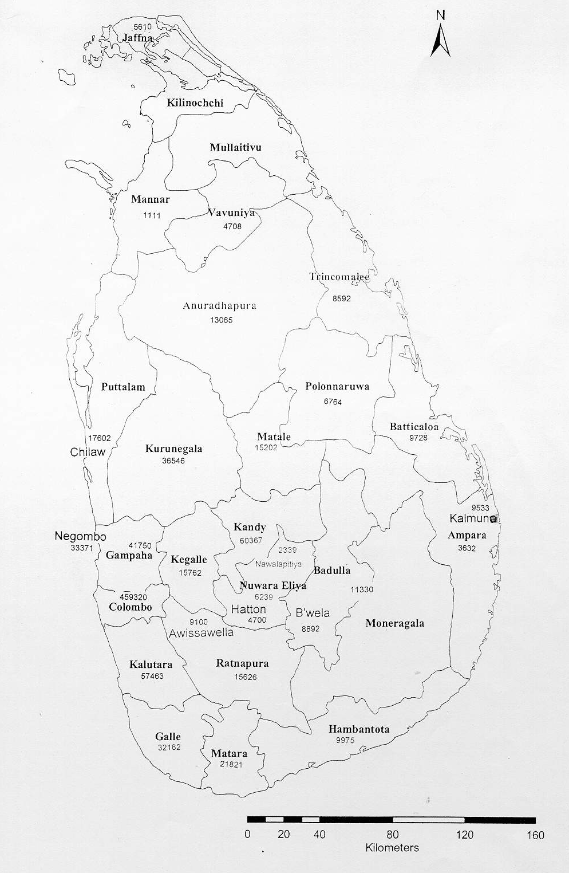
A - 7263
NCD–25609
CD –39595
NCD– 7171
CD– 14442
NCD–19464
CD– 43610
NCD-20881
CD- 38639
A-
NCD– 58?
CD –33600?
NCD–23334
CD– 23874
A -
NCD–21870
CD– 54573
NCD– 59183
CD– 33106
NCD-18194
CD – 80660
NCD – 469180
CD – 210991
NCD–46408
CD –136639
NCD–14582
CD– 45872
NCD–13800
CD– 10879
NCD–17879
CD – 17450
NCD – 4315
CD – 20735
NCD– 11533
CD – 83675
NCD– 14763
CD– 65704
NCD–34127
CD– 70426
NCD 30194
CD – 84574
NCD–14760
CD– 39694
NCD– 20422
CD– 68489
NCD–54948
CD– 57159
NCD–9024
CD –40362
NCD– 2825
CD – 5735
A-2515

A - 5665
NCD–10088
CD– 14354
A - 1348
A - 4597
A - 4375
A - 5301
A - 8477
A - 1636
A - 8344
A -16871
A - 6020
A -2951
A- 4781
A - 3923
A - 8613
A - 2071

A - 7760
A -9025
A - 4938

A - 14302

CD – CDMA
NCD – Non CDMA
A - ADSL
A - 13208
A - 31252

A-22199

A-26889
NCD– 49424
CD – 102348
A - 22634
A - 187959
NCD– 6200
CD– 37567
NCD– 6958
CD – 31522
NCD-72325
CD– 84783

